STTP Capstone Project: Children Human rights
SUBJECT: ADVANCED ENGLISH 3 ESO
OBJECTIVES: (Check the Perfil Competencial/Competences profile)

To use audio-visual resources to produce digital text in English in the course of engaging in critical thinking about Human Rights
To get familiarised with vocabulary related to Human RIGHTS in order to produce spoken and written texts in English.
To foster ss awareness of the importance of empathy in their active daily life as concerns human rights in their community

BLOCK: 1: 2, 6/ Block 2, 4/ Block 4 (Official Curriculum)

CONTENTS:
Learn about Human Right conceptual Vocabulary
Learn about abstract Nouns + Adjectives to relate to Human rights
Learn to blend use of audio + reading aloud activities to create short clips in English
Write an Article writing on a Human rights defender (AFAO)in their neighbourhood

FINAL PRODUCT: Create a walk gallery, thus making a audio-visual narrative in English about Human Rights related to Childhood aiming at bringing a closer look to their own context. That would be displayed in a Screen in the School's entrance hall.

Create a slide show using Windows Moviemaker: Reading aloud of Abbreviated list of the Universal Declaration of Human Rights.

Create a slideshow dedicated to AFAO which distributes food to people in need at the AMPA’s premises at school every month. Will include an interview with Julian Moreno (AFAO president. In English!!!)

Create a set of posters to illustrate the human rights children soldiers are denied.

Article writing: Writing about AFAO (Asociación Alonso de Ojeda which contributes with AMPA and School distributing food to the needy)

Creating a short 15 second clip based on the NYT education blog suggestion called the 15 second challenge: 15 second challenge

SEQUENCING

Lesson 1: Human rights and Children's rights. Human rights edTed lesson. Human Rights denied to children. + Quizlet + Reading alud clip
Detailed lesson plan has been uploaded
Lesson 2: Defendant spread the word. Peer teaching.SS from 1 Bach Inglés avanzado will give small chat about Abubacar Sultan.Jumbled sentenced activity based on a previous usmmary creted by 1 Bach ss.Creating a poster /Language assistant will be taking out ss and filming them while reading tehir abrreviated Human right. Child soldiers human rights Art Craft (Resources 4) + Human rights 15 second challenge activity
Lesson 3: Poverty +Hunger lesson: Ted talk. Poverty and hunger in Madrid. Save the Children Video.https://www.coloribus.com/es/adsarchive/tv-commercials/ayuda-en-accion-i-have-no-fear-18577955/
Lesson 4: Poverty defender: Creating a slideshow or Video. + Writing AFAO (Article writing)+ Creating video clips + AFAO Clip + Short Interview with AFAO Julian (AFAO president. In English!!!). SS will work in groups so that only 6 ss will be working on the AFAO CLIP + Interview. Most ss will be writing a 150-200 word article on AFAO. They will be handed in information about AFAO
We will handout ss with detailed ss on what we expect form the AFAO clip which can't be longer than 3-4 minutes. Language assistant will work with the set of ss who will interview AFAO president in order to create a 3 minute clip.
Lesson: 5 Gathering it all. Creating the Gallery on the Entrance Hall. Artcraft sticking + viewing of clips

RESOURCES:
Resources 1
ED-TED LESSON: HUMAN RIGHTS
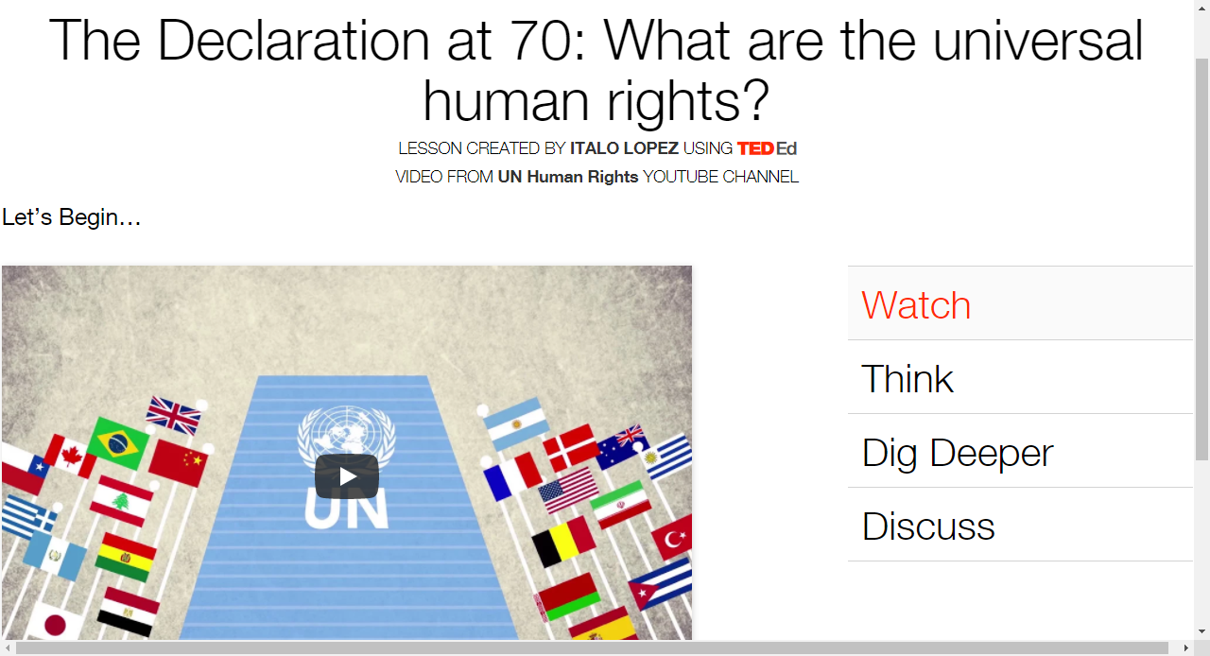
Resources 2
QUIZLET:
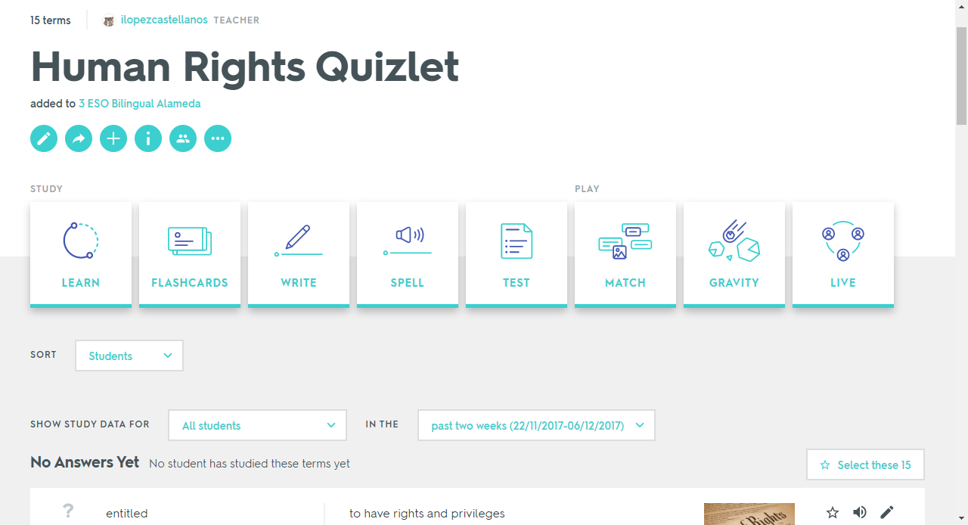

Resources 3:
HUMAN RIGHTS OR NOT
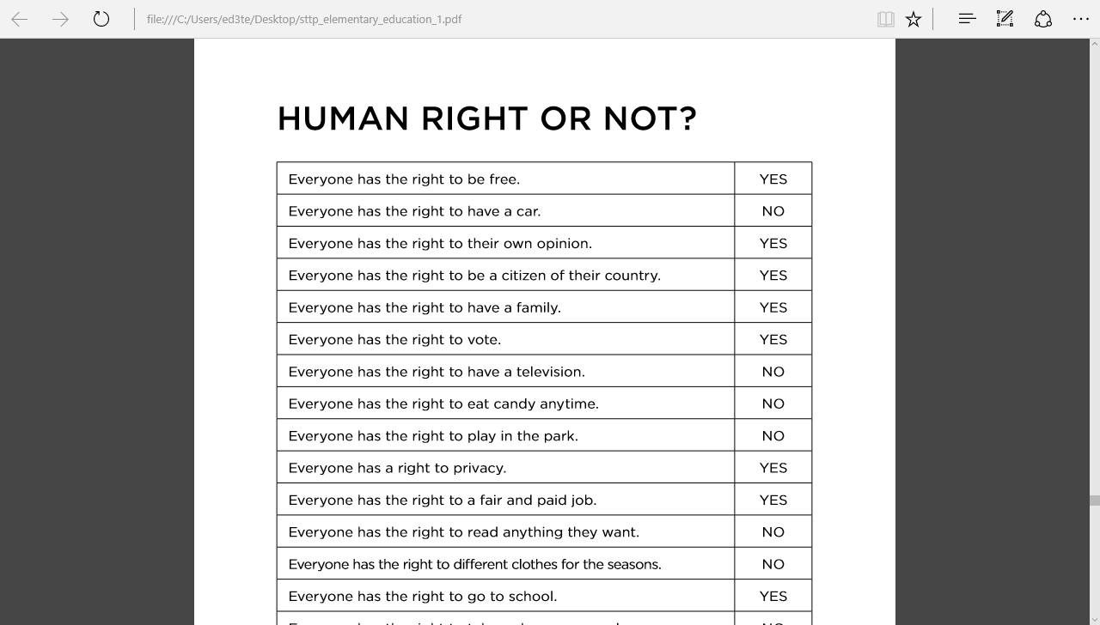
Pefil Competencial: Capstone Project
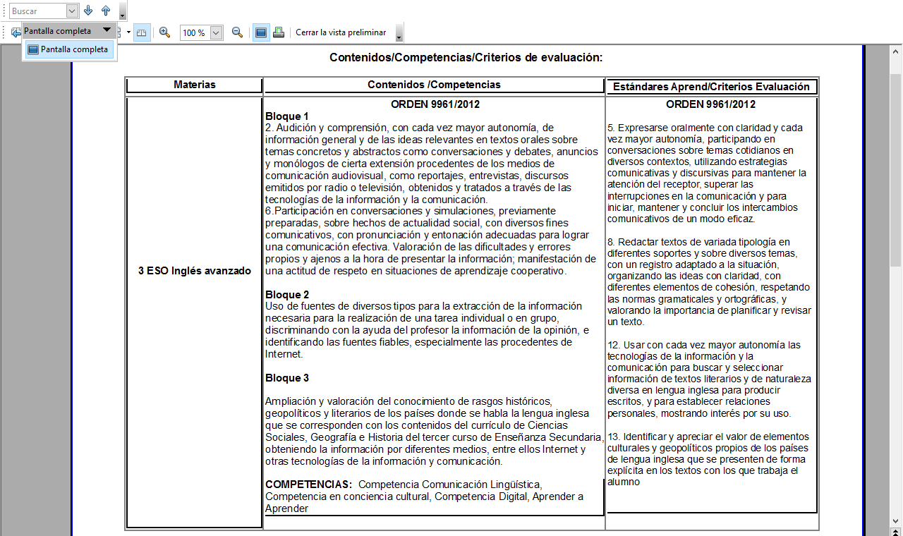

Resources 4:
