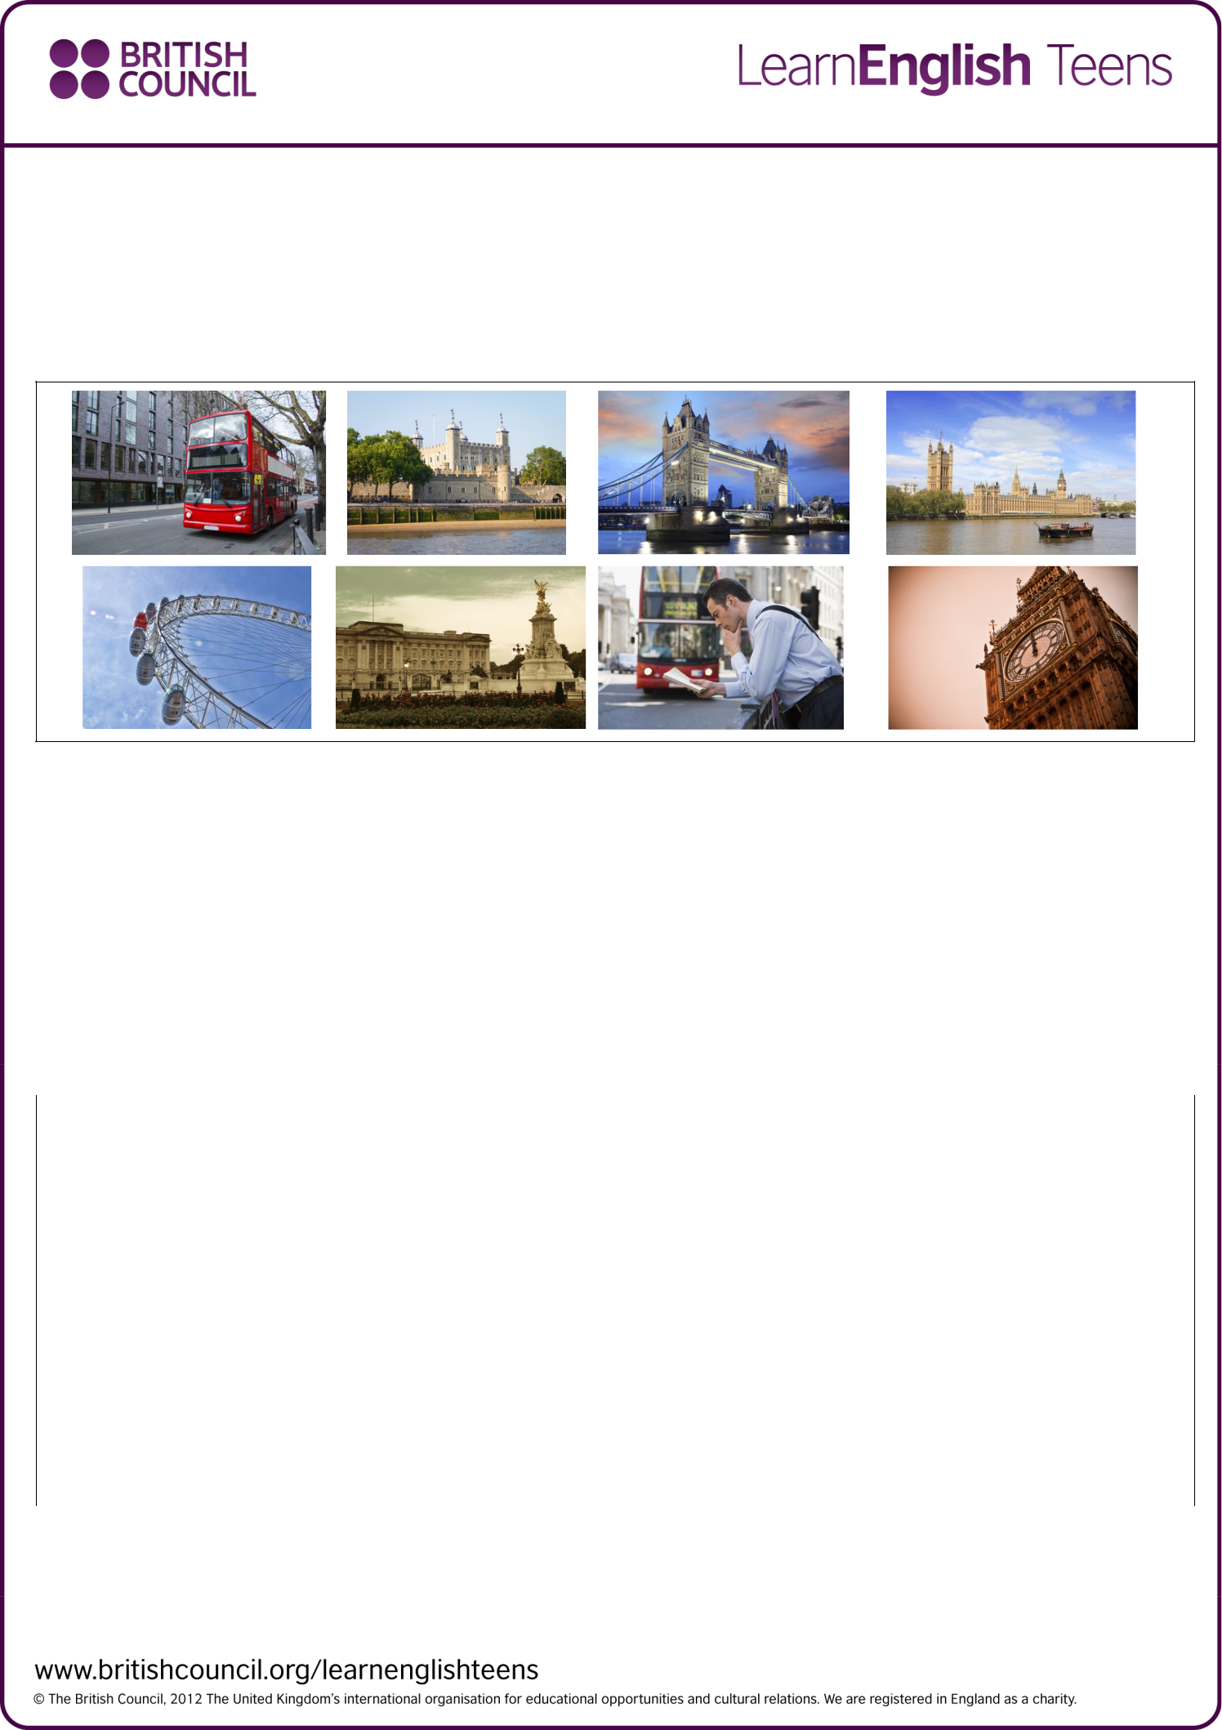
Listening skills practice: Tour of London – exercises

Take a tour of London by listening to this tour guide and do the exercises to practise your listening skills.

Preparation

Do this exercise before you listen. Draw a line to match the pictures with the words below.

8. Big Ben | 1.London bus | 5.London Eye | 2.Tower of London
7.Oxford Street | 3.Tower Bridge | 4.Houses of Parliament | 6.Buckingham Palace

1. Check your understanding: ordering

Do this exercise while you listen. Write a number (1-8) to put these places in order that the tour bus will visit them.

………2…. | Oxford Street
………1…. | Madame Tussauds, Museum
………7. | Tower of London
………5…. | London Eye
………4…. | Houses of Parliament
………8…. | Buckingham Palace
………3…. | Big Ben
………6…. | Tower Bridge

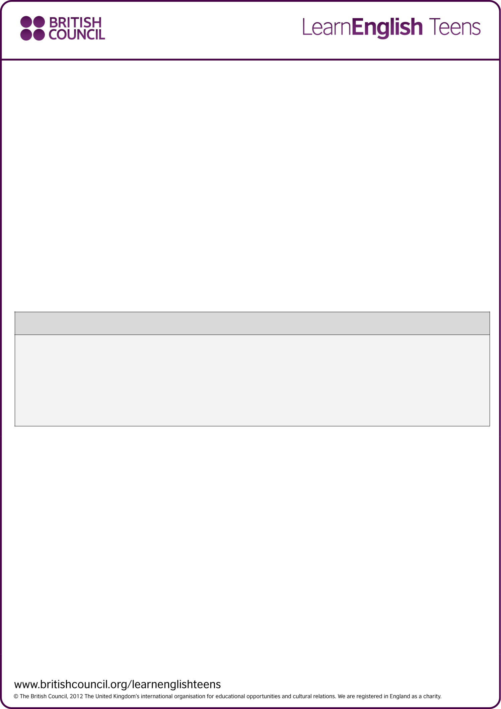

2. Check your understanding: multiple choice

Circle the best word to complete these sentences.

- The tour takes 2 / 3 / 4 hours.

2. | At Madame Tussaud’s you can see | maps of London / models of famous people / famous shops .
3. | Oxford Street is a famous street for | drinking tea / eating / shopping .
4. | The Queen lives at Buckingham Palace / the Tower of London / Tower Bridge .
5. | Big Ben is a tour guide / clock / bridge .
6. | You can see great views of London from Oxford Street / the Houses of Parliament / London Eye .

Have you ever been to any of these places?

Where did you go?

What did you do?

Which city would you like to take a tour in? Why?

