Pedro J. arana aritmendiz

Norwich 2017

https://padlet.com/arana05marmol/aranasworld

Objectives:

The developing of writing skills.

Oral Presentations based on arts

Methodology:

see, think, Wonder

(By claudia rey)

Students are shown a Painting: getting used to telling the diffference BETWEEN FACTS (data), deducting and speculating
Not an easy task they should learn before to classify their thinking routines properly into the three different categories before going any further.
ZOOMING (Examples for both)
Q.R. CODES. Quick Response Codes

Art-based projects

(by Claudia ferrada).

transmedia resources in culturally responsive classrooms
The National Gallery “Metamorphosis Titian 2012” Project
Two poems related to the topic

I Don’t teach Answers

(by Jeremy Harmer)
Minimal Invasive Education (MIE)
Self-Organized Learning Environment (SOLE)

STORY TELLING Jamie Keddie

Telling the skeleton of a story
Letting the students fill in with the “flesh”

Video telling
Adapted version to my project Hieronymus Bosch “The Garden of the Earthly Delights”

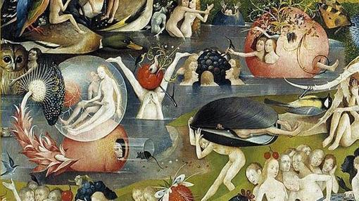

"The Garden of the Earthly Delights" (Task Project based on the methodology and techniques mentioned in the former post)
Jigsaw video watching (1): students Group A watch half of the video, group B the second half. Working in pairs retell the missing part to each other.
- Deeper insight (2)
- Jigsaw Reading (3) English
- Jigsaw Reading (4) Spanish as a foreign language. Reverse Translation.
- Alberti's Poem "El Bosco": (5 a/b)
- Story telling: Students choose a topic and make up a story based on the thinking routines: SEE, THINK, WONDER
- STORIES ARE MADE UP FOR THE CHOSEN PARTS OF THE PAINTING. Then the rest of the students either identify the figures or characters portrayed in the picture or point the chosen topics and then explain the meaning behind according to the stories they inspired.
- Activity Suitable for 1st Bachillerato Advanced Students in a Bilingual Setting.
e.g. "The Enchanted Piglet-Nun, and the Immaculate Fools"

Activities to do with my Students back in Spain:
General introduction animation
https://vimeo.com/studiosmack/paradise
2. Deeper Insight
https://youtu.be/fV8VduAtbxI
- Working with an English Test
https://www.theguardian.com/artanddesign/jonathanjonesblog/2017/jan/10/bosch-garden-of-earthly-delights-shows-a-world-waking-up-to-the-future?CMP=share_btn_link
4. Working with a test in Spanish
http://www.bbc.com/mundo/noticias-37029061
5. Working with Alberti's Poem.
a) "El Bosco" (Recited)
https://youtu.be/gzZKNRG4aNE
b) "El Bosco" (Musicians and singer)
https://youtu.be/tzId24wIomA

Word cloud for th text from The ^{Guardian}
QR codes for the activity


