Hi all,

- First of all, here’s the solution to exercises “a” and “b” on page 223.
En primer lugar, aquí tenéis la solución a los ejercicios a y b de la página 223.

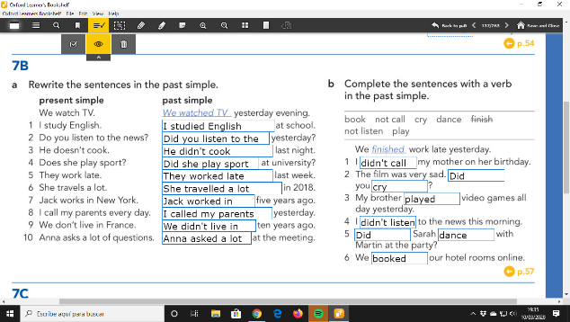

- Now, let’s move on to the rules for the pronunciation of the –ed endings.
Vamos a pasar ahora a las reglas de pronunciación de las terminaciones en –ed

RULES FOR THE PRONUNCIATION OF THE –ED ENDINGS:
/ɪd/ | /d/ | /t/
If the verb ends in the sound /t/ or /d/, you pronounce the -ed ending /ɪd/  Si el verbo termina en un sonido /t/ o /d/, la terminación –ed se pronuncia /id/  Examples:  invited /ɪnˈvaɪtɪd/  decided / dɪˈsaɪdɪd/ | If the verb ends in a voiced consonant sound apart from /d/ or a vowel, you pronounce the -ed ending /d/  Si el verbo termina en una consonante sonora aparte de /d/ o en una vocal, la terminación –ed se pronuncia /d/  Examples:  called /kɔːld/  cleaned /kliːnd/  loved /lʌvd/  Voiced consonant sounds:  /b/  /g/  /v/  /z/  /ð/  /ʒ/  /ʤ/  /l/  /r/  /m/  /n/  /ŋ/ | If the verb ends in a voiceless consonant sound, apart form /t/ you pronounce the -ed ending /t/  Si el verbo termina en una consonante sorda aparte de /t/, la terminación –ed se pronuncia /t/  Examples:  stopped /stɒpt/  helped /hɛlpt/  looked /lʊkt/  Voiceless consonant sounds:  /p/  /k/  /f/  /s/  /ʃ/  /tʃ/  /θ/

- Now let’s do ex 3a on page 101. Listen and repeat the sentences.

- Go to ex. 3b. Look at the verbs in the list. Circle the ones that belong to group 3 /id/. Listen and check
Find the solution on the next page.

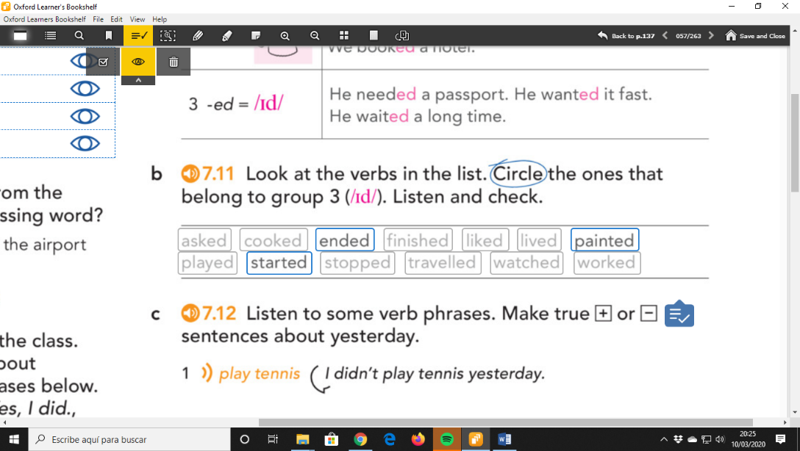
- Section 4 Vocabulary and speaking. Do ex. 4a on page 101. Number the past time expressions. Listen and check. Then listen and repeat.
- Optional: Do ex. 4c (Complete the sentence for each activity with a past time expression). You can send it to me by email.
- Now you are ready to do all the exercises on page 109. (Pronunciation and vocabulary). Check your answers.
- Did you have any problems? Please, send me an email if you have any questions.

Regards,
Cova

