LAB: THE STUDY OF CONSTANT ACCELETATION MOTION
- Previous concepts that you are supposed to know:
About motion: Position, trajectory, displacement, time, velocity, acceleration, graph time versus position, constant acceleration motion.
- Materials that you need in order to do this worksheet.
Computer, spreadsheet software, for example “Excel”. The rest of the material is provided.
INTRODUCTION
WHY? There are many objects in motion around us, and despite what you think most of them can be studied by using a simple mathematical method. Let us watch a piece of a movie which features a few types of motions. Now Watch Video #1
https://www.youtube.com/watch?v=2E3JDtqHaVM&t=185s
We are going to study two motions. The motion of Morpheus when he falls above the roof of the building, and the one of Neo, when he slides on the floor while he tries to save Trinity from a certain death. Will we be able to reach our purpose? And more importantly will Neo?

The results that we will obtain, in case we will, would they be extended to other everyday motions?
LAB # 1: DETERMINING THE GRAVITY OF THE EARTH.
Firstly, you must clearly know some previous concepts. We very often mistake the concepts mass and weight. However, they are completely different. Fill in this table to shows that you know what we are talking about.
Variable | Kind of Variable | Value  (Constant or variable) | Units (SI) | Measuring instrument.
Mass (m) | Base Variable | Constant | Meter (m) | Balance
Weight (W) | Derivate Variable | Depending on the place. | Newton (N) | Force meter

However, are this two variables independent or they are related to each other? See the pictures 1#, 2#, 3#, 4# and 5 # and fill in this table. These pictures show the weight of different objects measured by force meters.
Object | Mass (kg) | Weight (N) | Relationship (W/M) (N/kg)
#1 | 0,100 | 1 | 10,0
#2 | 0,200 | 2 | 10,0
#3 | 0,300 | 2,9 | 9,7
#4 | 0,400 | 3,9 | 9,8
#5 | 0,500 | 4,9 | 9,8
Average (N/kg) |  |  | 9,8

Build a graph that shows the Mass (independent variable) versus the value of the weight. Use a spreadsheet, for example “Excel”. If they are linearly proportional, draw the trend line and show the equation of the line.

Answer the next questions:
- Considering the results of the experiment, is there a relationship between the mass and the weight?
They are directly Proportional.
$M α W$

- What are the units of the constant that shows the relationship between both variables?
$${\vec{W}}_{Morpheus}$$
- What does that constant mean?
The constant means that the Earth exerts an attraction force of 9,8 N upon an 1 kg object.
$$1 N=1 kgm/{s^{2}}$$
- According with that equivalence, would you be able to express the constant that shows the relationship between Mass and Weight by using different units?
$$9,8 N/{kg}=9,8 \frac{kgm/{s^{2}}}{kg}=9,8 m/{s^{2}}$$
- Could you give an additional meaning to the constant?

The constant also means that every object falls towards the surface of the Earth with an acceleration of 9,8 m/s².

- Do you Know the name of this constant?
Gravity of Earth (g)
$$g=9,8 N/{Kg}=9,8 m/{s^{2}}$$
Keep this constant in your mind since, among other things, life is as we Know it due this number.
LAB # 2: DETERMINING THE MATHEMATICAL MODEL TO A FREE FALL MOTION.
You are going to study the motion of Morpheus when he falls above the roof of the building.
The next video shows an experiment in order to study this motion. In this experiment, a playmobil was released from 2,00 above the floor. Just behind the playmobil, on a wall, six red lines was drawn. There was a separation of 0,40 m between lines. The experiment was shot in slow motion. There were five repetitions. Watch the video and fill in the next two tables. Now Watch Video #2.

 |  | Morpheus #1 | Morpheus #2 | Morpheus #3 | Morpheus #4 | Morpheus #5
Initial Time (t₀) (s) |  | 4,62 | 2,48 | 2,48 | 2,24 | 4,16
Red Line | Pos. (m) | Time (t_{i}-t₀) (s) | Time (t_{i}-t₀) (s) | Time (t_{i}-t₀) (s) | Time (t_{i}-t₀) (s) | Time (t_{i}-t₀) (s)
1# | 0 | 0 | 0 | 0 | 0 | 0
2# | 0,4 | 0,22 | 0,28 | 0,28 | 0,26 | 0,25
3# | 0,8 | 0,35 | 0,36 | 0,36 | 0,37 | 0,39
4# | 1,2 | 0,44 | 0,46 | 0,46 | 0,46 | 0,46
5# | 1,6 | 0,54 | 0,52 | 0,52 | 0,53 | 0,54
6# | 2 | 0,58 | 0,59 | 0,59 | 0,58 | 0,6

Position (m) | Time (av) (s) | T² (s²)
0 | 0,00 | 0,00
0,4 | 0,26 | 0,07
0,8 | 0,37 | 0,13
1,2 | 0,46 | 0,21
1,6 | 0,53 | 0,28
2 | 0,59 | 0,35

Answer the next questions:
- Which line corresponds to position 0,00 m?
The first line (1#)
- Which line corresponds to the maximum position?
The sixth line (6#). The maximum position is 2,00 m.
- Which is the speed of free fall of Morpheus when he released the hand of Neo?
The initial speed is 0 m/s.
- Build a graph that shows the time (independent variable) (Take the average values) versus the position of the playmobil. Use a spreadsheet, for example “Excel”.

- Build a graph that shows the square time (independent variable) (Take the average values) versus the position of the playmobil. Use a spreadsheet, for example “Excel”.

- Considering the results of the experiment, is there a relationship between the time and the position and square time and position? If they are linearly proportional, draw the trend line and show the equation of the line.

They are directly Proportional.
$Y α T^{2}$

- What are the units of the constant of the equation of the line that shows the relationship between square time and position?
$$5,77m/{s^{2}}$$
- Does this constant have any physical sense?
This value is the half of the Gravity of Earth approximately.
$$5,77 m/{s^{2}}·2=11,54 m/{s^{2}}≈9,8 m/{s^{2}}$$
- Considering your conclusion, has any error been committed? Could this error be quantified?
Yes. The constant should have been 9,8 m/s².
$$\% Error= \frac{\left(11,54 m/{s^{2}}- 9,8 m/{s^{2}}\right)}{9,8 m/{s^{2}}}·100=17,8 \%$$
- Could you write same reasons that could be behind this error?
- Finally, could you write a mathematical model for this kind of motion (Use the value of the gravity of the Earth)?
$$y= 1/2·g·t^{2}=4,9m/{s^{2}}{·t}^{2}$$
LAB # 2: DETERMINING THE MATHEMATICAL MODEL TO A CONSTANT ACCELERATION MOTION.
You are going to study the motion o Neo when he slides on the floor while he tries to save Trinity from a certain death.
The next video shows an experiment in order to study this motion. In this experiment, a wood block (Neo block) is coupled by a rope and pulley to a helicopter. When the Neo Block is released, it slices on a horizontal plane. Just behind the wood block, six red lines was drawn. There was a separation of 0,14 m between lines. The experiment was shot in slow motion. There were five repetitions. Watch the video and fill in the next two tables. Now Watch Video #3
 |  | Neo #1 | Neo #2 | Neo #3 | Neo #4 | Neo #5
Initial Time (t₀) (s) |  | 0,36 | 0,96 | 1,45 | 1,44 | 1,78
Red Line | Pos. (m) | Time (t_{i}-t₀) (s) | Time (t_{i}-t₀) (s) | Time (t_{i}-t₀) (s) | Time (t_{i}-t₀) (s) | Time (t_{i}-t₀) (s)
1# | 0,00 | 0,00 | 0,00 | 0,00 | 0,00 | 0,00
2# | 0,14 | 0,30 | 0,34 | 0,32 | 0,36 | 0,34
3# | 0,28 | 0,46 | 0,5 | 0,50 | 0,50 | 0,49
4# | 0,42 | 0,57 | 0,61 | 0,59 | 0,61 | 0,58
5# | 0,56 | 0,67 | 0,72 | 0,70 | 0,71 | 0,69
6# | 0,70 | 0,74 | 0,81 | 0,75 | 0,79 | 0,80

Position (m) | Time (av) (s) | T² (s²)
0 | 0,00 | 0,00
0,14 | 0,33 | 0,11
0,28 | 0,49 | 0,24
0,42 | 0,59 | 0,35
0,56 | 0,70 | 0,49
0,7 | 0,78 | 0,61

Answer the next questions:
- Which line corresponds to position 0,00 m?
The first line (1#)
- Which line corresponds to the maximum position?
The sixth line (6#). The maximum position is 0,70 m.
- Which is the speed of the Neo Block at the beginning of the experiment?
The initial speed is 0 m/s.
- Build a graph that shows the time (independent variable) (Take the average values) versus the position of the Neo block. Use a spreadsheet, for example “Excel”.

- Build a graph that shows the square time (independent variable) (Take the average values) versus the position of the Neo Block. Use a spreadsheet, for example “Excel”.

- Considering the results of the experiment, is there a relationship between the time and the position and square time and position? If they are linearly proportional, draw the trend line and show the equation of the line.

They are directly Proportional.
$X α T^{2}$

- What are the units of the constant of the equation of the line that shows the relationship between square time and position?
$$1,16m/{s^{2}}$$
- Does this constant have any physical sense?
This value is the half of the half of the acceleration of the Neo Block approximately.
$$a=1,16 m/{s^{2}}·2=2,32 m/{s^{2}}$$
- Finally, could you write a mathematical model for this kind of motion (Use the value of the gravity of the Earth)?
$$x= 1/2·a·t^{2}$$

You will study that behind a constant acceleration there is always constant net force.
- Would you able to draw the forces that are actin upon Morpheus and Neo by using vectors?
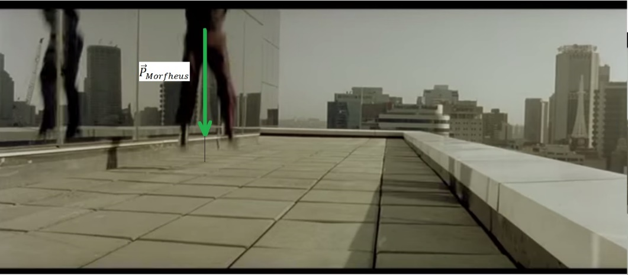
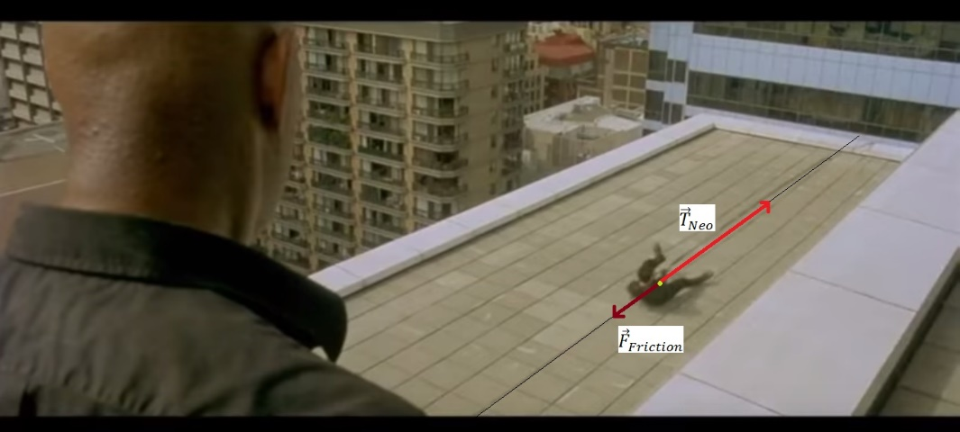

CONCLUSIONS:
Answer the next questions:
- Are the motions of Neo and Morpheus the same kind of motion?
Yes, they both are constant acceleration motion.
- If the initial speeds and positions had not been 0 m/s and 0 m, Could the same mathematical model been utilized to show the relationship between time and position?
No, in that situation you must utilize this mathematical model:
$$x=x_{0}+v_{0}t+1/2·a·t^{2}$$
$$x_{0}=initial position$$
$$v_{0}=initial speed$$

- Are there observable motions like these in nature? Could you write same examples?

- And the most important, what happened with Trinity?
Now Watch Video #4

