SOCIAL SCIENCE PROJECT
SPAIN IN THE 20TH AND 21TH CENTURIES

1. Who was Primo de Rivera?

Was he voted by people?

2. Write sentences about 1931 including this words:
- women:

- church:

- autonomous:

-exile:

4. Investigate and write a poem by Federico García Lorca and another by Antonio Machado.

5. Spanish Civil War.
- When did it start? When did it finish?

- Explain what two sides fought each other and what they supported.

6. Guernica:
Find out the meaning of these figures:
- Bull:
- Woman holding a child:
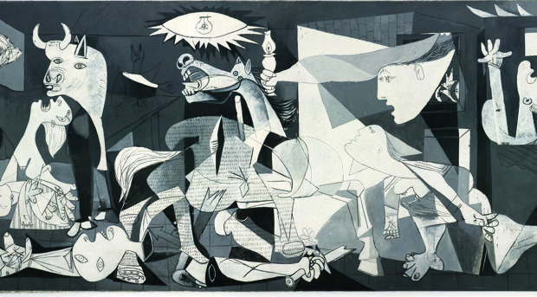

7. Watch this video and answer the questions.
https://www.youtube.com/watch?v=EemzZxSxdlI

- How many people went on exile?

-Explain how was life after the war.

8.Explain briefly what was the “Transición” ( + - 20 words )

9. Name all the Presidents of the Government after Franco´s death

10. Put in order these events: Fernando Tejero tries a coup , Spain joins the Economic European Union, Felipe VI becomes king of Spain, the Euro replaces the Peseta.

