NAME:

You have to find the information in this web https://www.comunidad.madrid/servicios/madrid-mundo/publicaciones-union-europea

PART 1: ARCHITECTURE OF EUROPE
https://www.comunidad.madrid/sites/default/files/conoces_la_arquitectura_en_la_ue_bvcm021003.pdf

Exercise : Where are these famous places?
BUILDING | COUNTRY
Schonbrunn Palace
Amberes Central Station
Eiffel tower
Coimbra University
Philharmonie

PART 2: CUISINE (GASTRONOMY)

https://www.comunidad.madrid/sites/default/files/conoces_la_gastronomia_en_la_ue_bvcm019570_0.pdf

Exercise: Explain the gastronomy of 2 countries in the European Union. You can include name of food, recipes, pictures or drawings, etc.

PART 3 : ART

https://www.comunidad.madrid/sites/default/files/conoces_la_pintura_en_la_ue_bvcm019384_0.pdf

Exercise: Complete
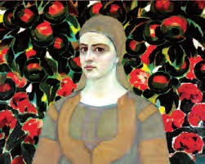 | Name of the painting:  Author:  Country:
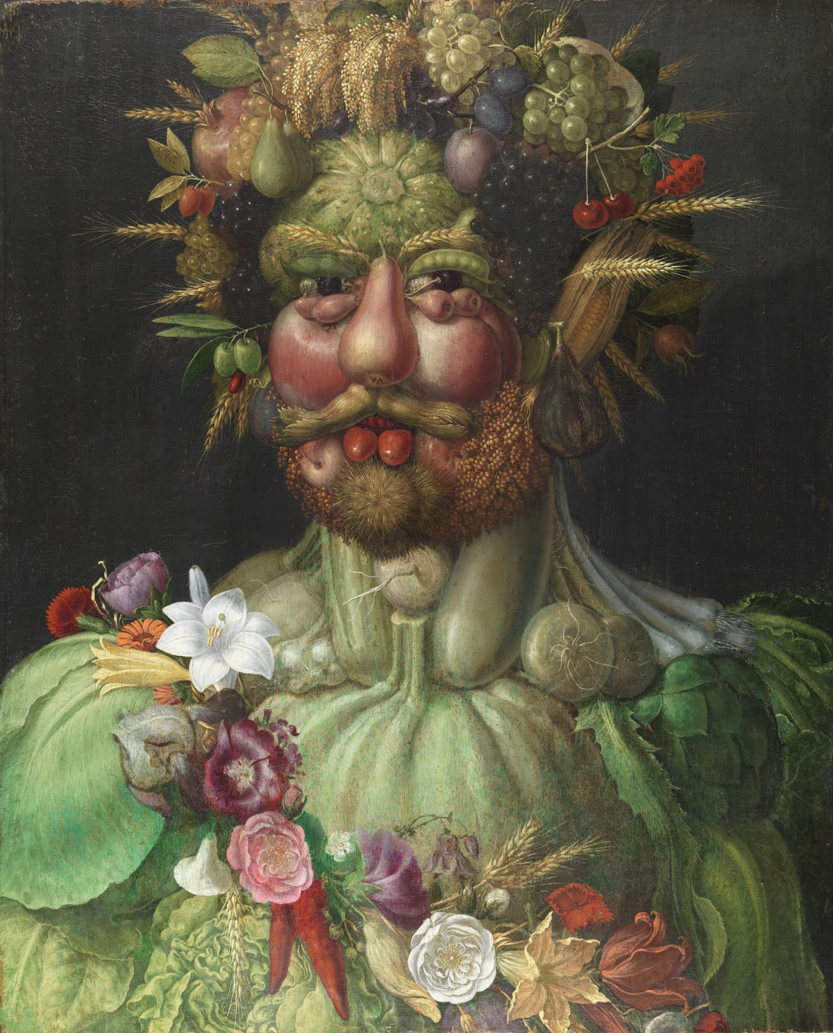 | Name of the painting:  Author:  Country:
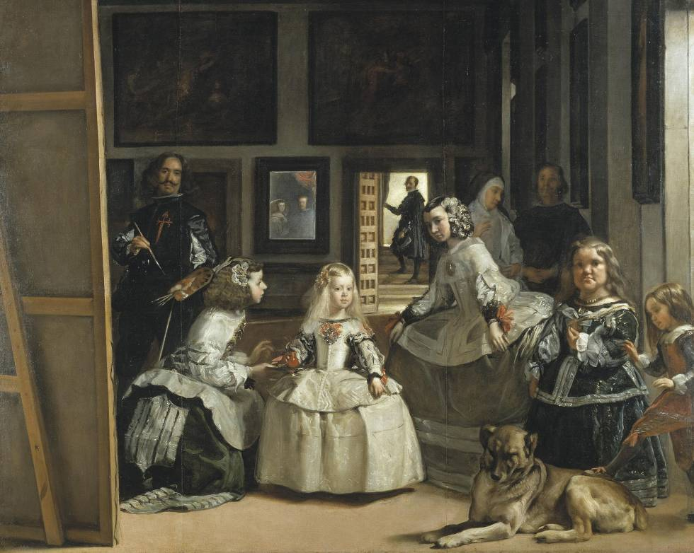 | Name of the painting:  Author:  Country:
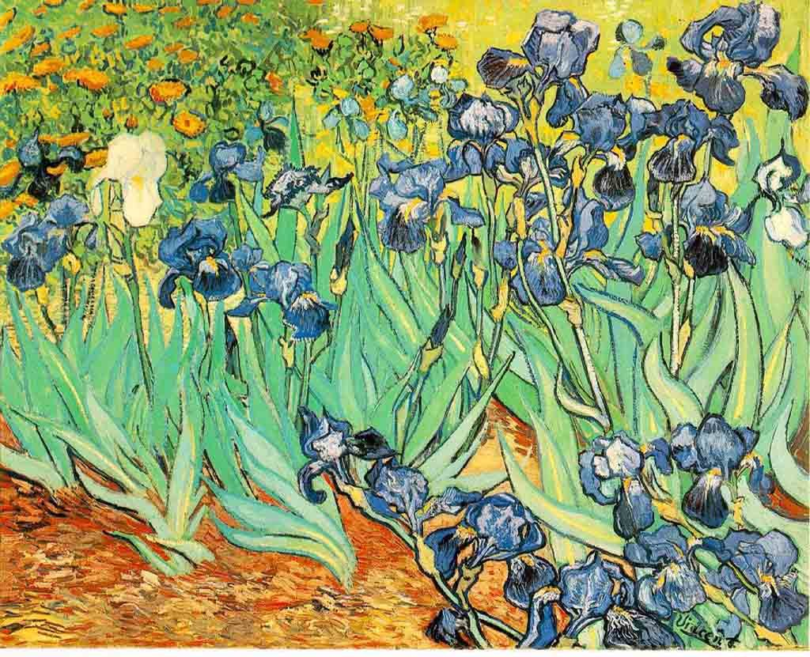 | Name of the painting:  Author:  Country:

PART 4: ANIMALS AND PLANTS

https://www.comunidad.madrid/sites/default/files/conoces_la_naturaleza_en_la_ue_bvcm019394_0.pdf

Exercise: Complete the table

COUNTRY | ANIMAL | PLANT
????? | Lipicanec horse | Linden
Spain | ?????? | Holm oak
France | ?????? | ??????
?????? | ?????? | Olive tree

