Name: ______________________________ Date: ___________________
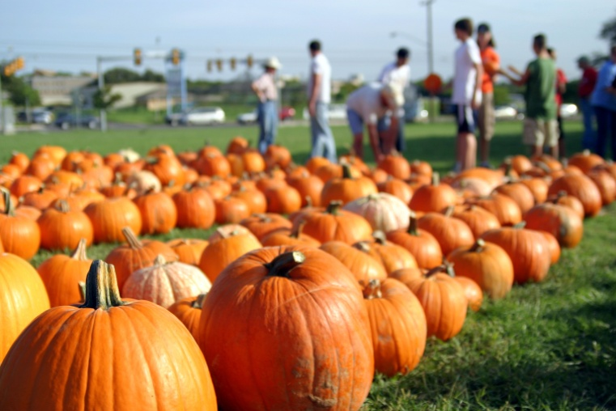
You are each a pumpkin in Mr. Smith’s pumpkin patch.
I, your teacher (Blanca), am shopping for a pumpkin to carve to make a Jack-o-lantern and put in my apartment for Halloween. You, the pumpkin, have to write to me and tell me why you are not a good pumpkin for me to choose. You don’t want me to carve you! You don’t want to die!!!
You should use creative adjectives to enhance your writing. Also use punctuation (. , ; “” ? !) and connectives (and, but, so, however, consequently, although, besides…) to organize your sentences and paragraphs.
________________________________________________________________________________________________________________________________________________________________________________________________________________________________________________________________________________________________________________________________________________________________________________________________________________________________________________________________________________________________________________________________________________________________________________________________________________________________________________________________________________________________________________________________________________________________________________________________________________________________________________________________________________________________________________________________________________________________________________________________

