Country: ________________ Name: _______
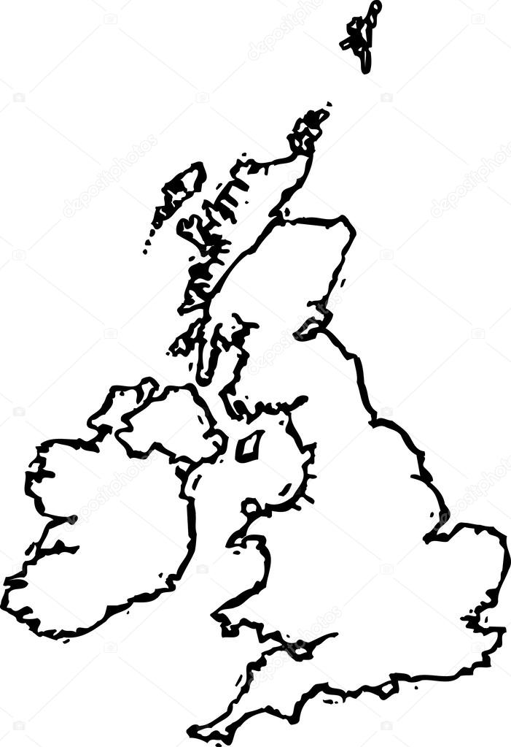
• The Spanish name for _________________is ____________________.
• ____________ is bordered:
- to the north by __________________________.
- to the south by __________________________.
- to the east by ___________________________.
- and to the west by __________________________.
• The language spoken in ____________________ is __________________.
• The capital of __________________ is ___________________.
• The currency used in __________________ is the _______________.
• The typical food in ______________________ is ___________________.
• ______________ is the most popular sport in ____________________.
• This is the flag of ________________________:

