Dear Ana, Clara and Matthew,
Trying to explain deeply my work, I send you some more points:

- Only describing, but not actually producing the assessment tools.

https://padlet.com/casanovalopez/4nt504euz4z9

- Unit assessment:
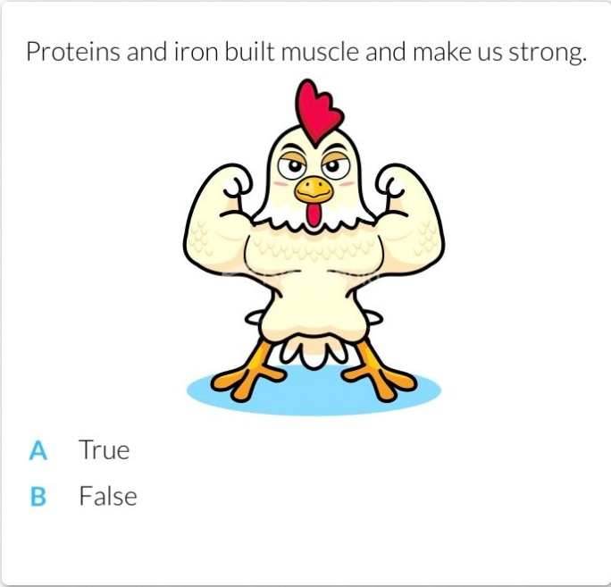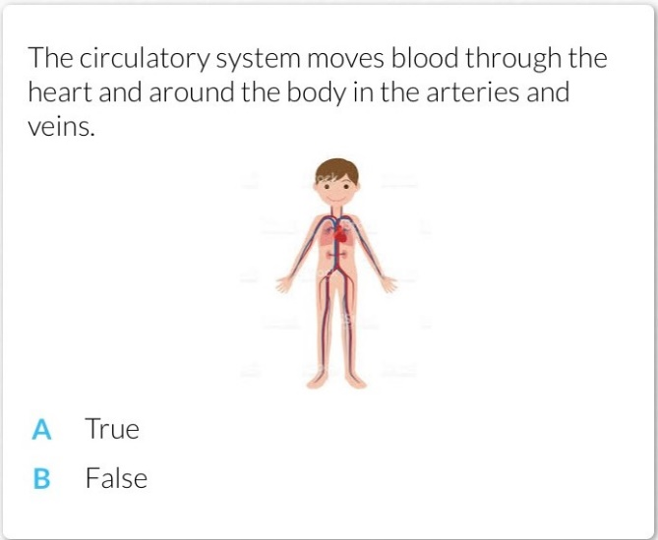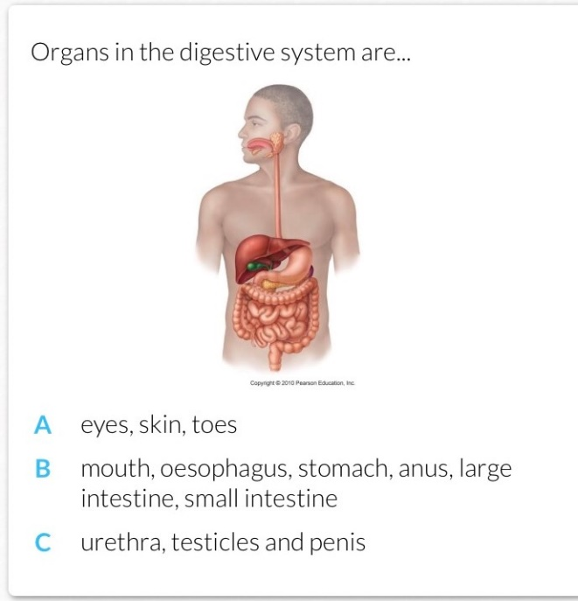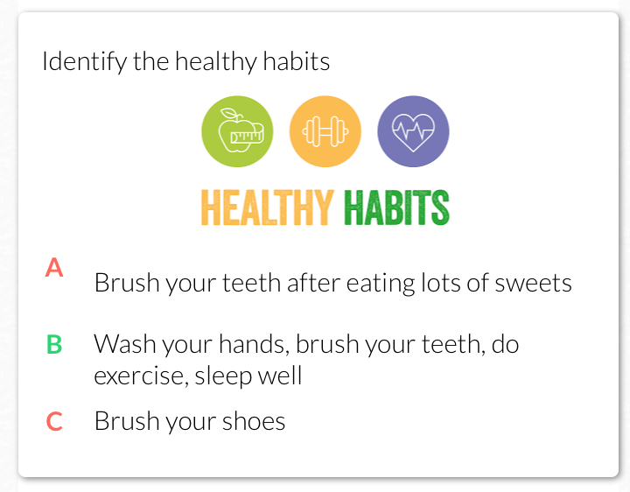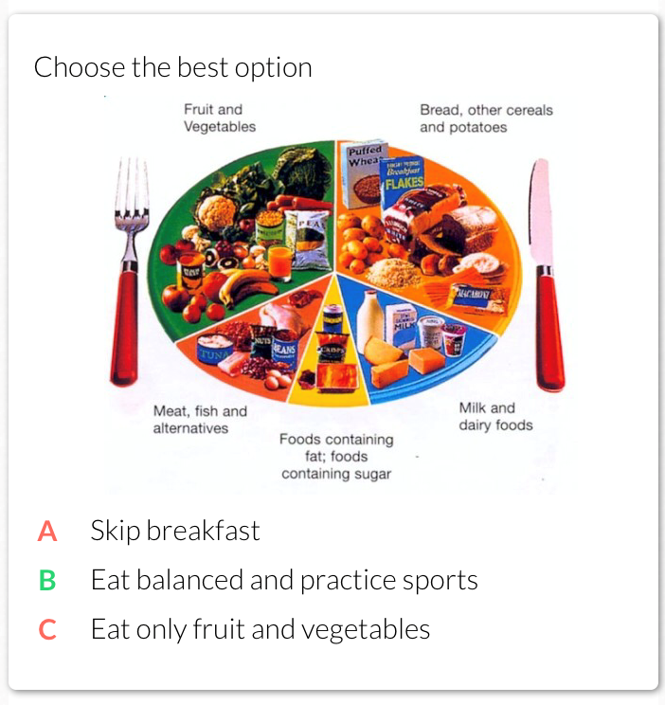
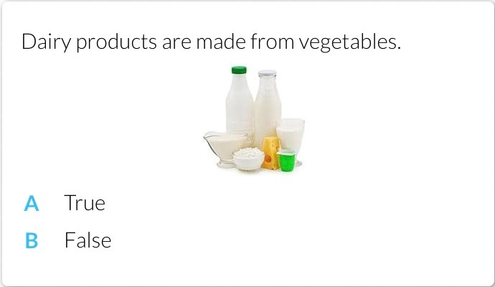

- Having very vague assessment criteria such as a checklist with sections like "attitude", "behaviour", "use of English" and so on, but without any descriptors of what constitutes the desirable behaviour or the target elements of English to be used.
- Assessment criteria:
Assessment criteria
1. Identifies the main body organs related to the nutrition and digestive process establishing a connexion between them.

2. Locates the organs and establishes a relation between them in the nutrition and digestive process.

3. Recognises the importance of a balanced diet following the different groups of food and their benefits in our health as well as to prevent illnesses.

4. Understands the benefits of practising sports, resting or maintaining hygiene habits as positive in human lives.

- not completing some of the sections, especially the justification and/or reflection.
´Within the process of the unit I have included many improvements and variations. Although I use aids as scaffolding, the group shows the necessity of a very explicit and detailed exposition when presenting the theory. Among all methods, the group seem to work better when doing so in cooperative work. Interviewing in pairs or small groups functions extraordinary also and a written record gives a great amount of reliable information. When dealing with this method, scaffolding is easier to manage, as well as attention. Since most of the students are extrovert, they participate.
As for the TIC sessions, I have seen the alternative of using “Plickers” as a more reliable task than “Kahoot” since it is more difficult for students to copy to each other. On the other hand, they love these sessions so we will keep on working on them. Neverthelss, a high number of students has no access to the Internet at home so despite the “Class Dojo”, it is not easy for them to participate in online blogs.
To finish, I cannot forget to bring to light the gratifying results of using this last platform that allow me to communicate directly with parents, posting information about school and lessons and what is more important, it largely engages students´.

- Not having put any of the assessment plan into practice.
https://padlet.com/casanovalopez/4nt504euz4z9
Not using personal details, this Padlet activities has been used in third grade being part of my didactic plan for this course and first term.

- Creating a final exam without having taken into account feedback on the task from unit 3.

- Many of these exams either eliminated the need for any language production beyond single words and/or required complex language production without any scaffolding.
In order to include varied tasks for assessment, I exemplified two specific evaluation tasks as tests (Kahoot and Plickers). Notwithstanding, I attach one more test as follows:

FINAL TEST

1. Answer the question. Complete.
How does the digestive process work?
The food …………………………………….. after …………………………………………. Then ………………………. Finally……………………………..
2. What are the main steps in the nutrition process?
1.-
2.-
3.-

3. Label the parts that you know.
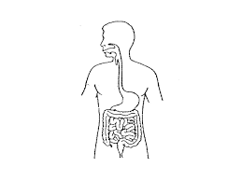

4. Define in your own words.
- Mouth, oesophagus, stomach, intestines.

5. Complete the sentences with your opinion.
To practice sport help us to…
A good diet and sport help us to…
You should eat … pieces of … everyday.

Before starting the test, the following is played in the Smart Board to introduce the questions and help students.
Speaking\Speaking cards.pptx
Reading and writing activities\Reading and writing.pptx

- A lack of formative assessment including peer and self-assessment-
- A general lack of scaffolding.
https://play.kahoot.it/#/k/d7d39526-79da-430e-b63c-1fdc92656039
Any of the interactive tools I provided (Kahoot and Plickers) involve a peer and self-assessment when practicing once they answer the questions in a “game way”. It is clear when it is shown the score diagram. Furthermore, it also introduce and help for understanding such an scaffolding through images, helping tips and the stress-free atmosphere every game provides to children.

- A lack of language criteria.
Language-related assessment criteria
- Question words: who, how many, where, what, why.
Ex. How does the digestive process work?
What are the main steps in the nutrition process?

- Prepositions of place: in, on, under, next to.
Ex. In the digestive scheme: where can you identify the large intestine?

- Sequence words: then, next, after that, etc.
Ex. Explain the digestive process.

- Mouth, oesophagus, stomach, intestines. Veins, heart, arteries.

- There is / are.
Ex. There are … main steps /organs in the digestive process.

- Present simple of the verb to be.
Ex. To practice sport help us to…

- Speak and write in complete sentences.
Ex. A good diet and sport help us to…

- Should / shouldn’t + infinitive.
Ex. You should eat … pieces of … everyday.

I attach one more time the complete work I made. I deeply wish you appreciate it.
Thank you.

https://padlet.com/casanovalopez/4nt504euz4z9

