Country: ________________ Name: _______
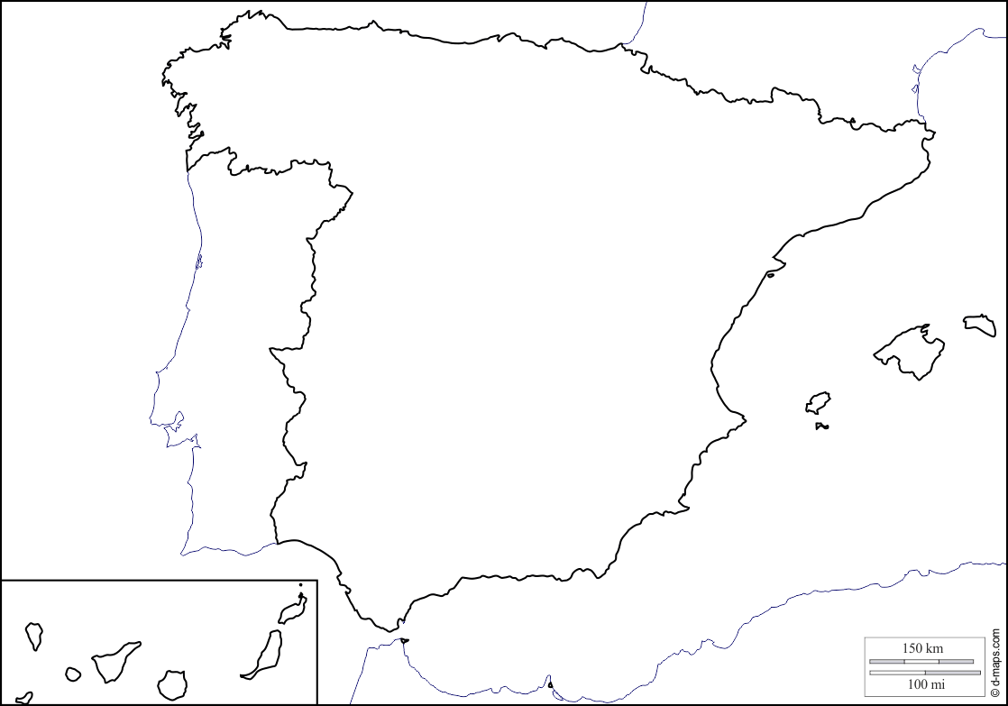

• The Spanish name for _________________is ____________________.
• The language spoken in ____________________ is __________________.
• __________________ is located in Europe.
• The capital of __________________ is ___________________.
• The currency used in __________________ is the _______________.
• In Spain they drive on the right-hand side of the road.
• The typical food in ______________________ is ___________________.
• ______________ is the most popular sport in ____________________.
• This is the flag of ________________________:

