**TYPES OF ELEMENTS AND CHEMICAL BONDS**

This pedagogical resource has been developed by Pilar Arranz as the Final Project of the course: “Inquiry-Based Learning for Science Teachers” into the PFLE2017 of Community of Madrid.

It is a Physic & Chemistry resource developed focusing on the first cycle of ESO and more concretely for 2ºESO grade; although it can be adapted and extended to 3ºESO grade.

This resource consists basically, but not only, of a worksheet which objective is to introduce students to the following concepts:

* Types of chemical elements.
* Periodic Table.
* Molecular and crystal structure.
* Which types of elements arrange each other to form compounds.

Following the link below, you will find some clarifications about the worksheet related to Inqury-Based Learning Methodology:

[**https://www.powtoon.com/c/d98rZeE7Qfu/1/m**](https://www.powtoon.com/c/d98rZeE7Qfu/1/m)

To know more about this methodology, you can visit the site developed by the course attendees, encouraged by Pilar Collado who created it:

[**https://inquirybasedsciencelearning.wordpress.com/**](https://inquirybasedsciencelearning.wordpress.com/)

To help you to engage and introduce your students in this new and awesome way to learn, you can use the next video link:

**https://www.powtoon.com/c/ee6jK1UVnKa/1/m**

I hope my work is helpful for you. Thanks for taking it into consideration.

**TYPES OF ELEMENTS AND CHEMICAL BONDS**

Are all the atoms equal? How do atoms arrange each other to form compounds?

**Part 1**

Are Calcium and Aluminum the same category of element?

So far 118 chemical elements have been discovered and classified into different categories. The number of chemical compounds is infinite but not all the element combinations are possible. Let’s take a look at them and discover their secrets.

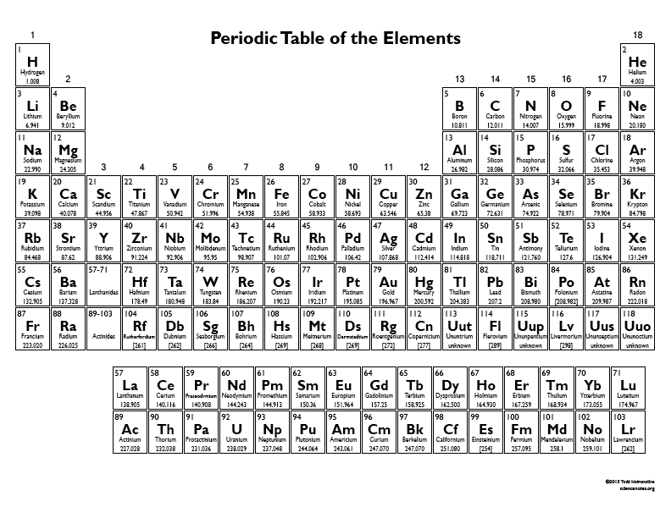

**Types of elements**

1. Look at the set of cards given by your teacher and identify the name, symbol and some basic properties of the element.
2. Locate the element on the Periodic Table and color the table cell with the same color as the card. Each color corresponds to a different category.
3. **Noble Gases** are one of the categories of the Periodic Table. Looking at the properties on the cards, which color do you think correspond to the category of **Noble Gases**. List the Noble Gases.
4. There are only 11 **Non Metals** elements. Looking at the Periodic Table and knowing that elements from the same category are close on the Periodic Table try to write them down and color them above.
5. Aluminum (Al), iron (Fe), copper (Cu), gold (Au), Silver (Ag) or chrome (Cr) are elements classified into the same category. Give a name to this category.

**Part 2 – Types of chemical bonds**

**Set A Set B Set C**

H2O AlN H2

CO2 FeO O2

NO2 NaCl Br2

C6H12O6 AgI S8

CCl4  CaS F2

HCl Au2O3 I2

1. What categories of elements are bonded in Set A and Set C. This bond is called **Covalent Bond**.
2. Which categories of elements are bonded in Set B? This bond is called **Ionic Bond**.
3. Noble gases appear in nature as isolated atoms so that they are just represented by the symbol of the element itself without subscript. Explore and explain why C (Carbon) is also represented only by its symbol.
4. Metals are also represented only by their symbols but atoms from the same metal bond to each other to form infinite crystal lattice making **Metallic Bond**. What does happen when atoms from different metals come together? Do they join together like the Noble Gases? Can you explain why or why not?
5. Explain in your own words the differences and similarities between covalent bond, metallic bond and ionic bond, based on the categories of elements that join to form them.

|  |  |
| --- | --- |
| **He**  Helium  Monatomic gas  Extremely stable tending not to form chemical bonds | **Ne**  Neon  Monatomic gas  Extremely stable tending not to form chemical bonds |
| **Ar**  Argon  Monatomic gas  Extremely stable tending not to form chemical bonds | **Kr**  Krypton  Monatomic gas  Extremely stable tending not to form chemical bonds |
| **Xe**  Xenon  Monatomic gas  Extremely stable tending not to form chemical bonds | **Rn**  Radon  Monatomic gas  Extremely stable tending not to form chemical bonds |
| **Al**  Aluminium  Shiny appearance  Good conductor | **Li**  Lithium  Shiny appearance  Good conductor |

|  |  |
| --- | --- |
| **O**  Oxygen  Diatomic molecule O2  Gas at room temperature | **C**  Carbon  Appears in two allotropic forms: graphite and diamond |
| **F**  Fluorine  Diatomic molecule F2  Gas at room temperature | **I**  Iodine  Diatomic molecule I2  Solid that easily sublimes |
| **P**  Phosphorus  Appears in different molecular allotropic forms | **Se**  Selenium  Appears in different molecular allotropic forms |
| **Ca**  Calcium  Shiny appearance  Good conductor | **Mg**  Magnesium  Shiny appearance  Good conductor |

|  |  |
| --- | --- |
| **H**  Hydrogen  Diatomic molecule H2  Gas at room temperature | **Fe**  Iron  Shiny appearance  Good conductor |
| **Cu**  Copper  Shiny appearance  Good conductor | **Ag**  Silver  Shiny appearance  Good conductor |
| **Au**  Gold  Shiny appearance  Good conductor | **Fr**  Francium  Appears in different molecular allotropic forms |
| **Ti**  Titanium  Shiny appearance  Good conductor | **Pt**  Platinum  Shiny appearance  Good conductor |