**UNIT 3: MY FAMILY**

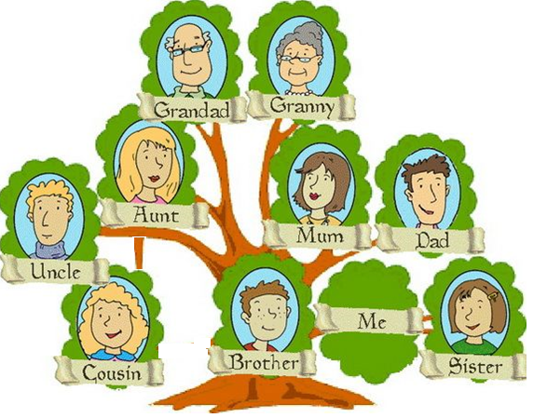

|  |  |
| --- | --- |
| * Granny / Grandmother  * Grandad / Grandfather  * Mum / Mother  * Dad / Father | https://s-media-cache-ak0.pinimg.com/736x/90/59/7d/90597d2c6770fe4993de75e3b780bfb7.jpgBaby |

**GRAMMAR**

|  |  |
| --- | --- |
| **Para preguntar y responder quién es alguien** | |
| Who’s this? / Who is this?  This is my uncle. | ¿Quién es este?  Este es mi tío. |

|  |  |
| --- | --- |
| **Para decir cómo es tu familia** | |
| I’ve got a big family.  I’ve got a small family. | Tengo una familia grande.  Tengo una familia pequeña. |