SPEAKING SKILLS
ACTIVITY 1.
YOU HAVE TO TRY TO SPEAK IN ENGLISH AT LEAST 2 MINUTES ABOUT THIS PICTURE.
( TALK ABOUT PETS )
DO YOU LIKE ANIMALS? WOULD YOU LIKE TO HAVE A PET? WHY?
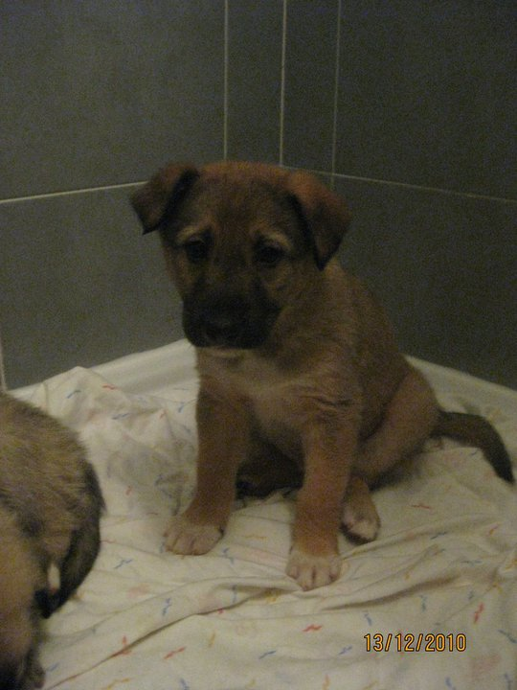

ACTIVITY 2:
WRITING : You should write a small composition about picture 1.

