PLAN DE ACCIÓN: ACOGIDA AUXILIARES DE CONVERSACIÓN
Motivación | Los Auxiliares de Conversación son personas importanets en el Proyecto Bilingüe por lo que es necesario prestarles la atención debida a la vez que facilitarles su adaptación al Centro. La acogida del Auxiliar de Conversación es, sin lugar a dudas, un momento clave que determinará en parte el clima de las relaciones personales, la empatía con alumnos y profesores, etc.  Desde el inicio de curso es necesario un consenso entre todos los Departamentos implicados en el trabajo del Auxiliar de Conversación para así obtener el mejor rendimiento del mismo durante su estancia. Cada profesor debe proporcionarle un guión con aquellos aspectos que deben tenerse en cuenta en el desarrollo de la clase como por ejemplo cómo se motiva a los alumnos que no participan en clase, cómo se fomenta la práctica oral, cómo van a trabajar auxiliar y profesor conjuntamente en el aula, etc. Además, el Auxiliar debe ser informado del horario y características propias del centro, las actividades en las que puede participar, donde está la sala de profesores, la biblioteca, los despachos del Equipo Directivo, las aulas específicas, el patio, los departamentos, los baños, las fotocopiadoras, los ordenadores que puede usar, la cafetería, contraseña wifi, etc.
Objetivo | Guiar y ayudar al auxiliar de conversación en su adaptación en el Centro.
Acciones | Elaboración de un documento con pautas básicas sobre el funcionamiento del Centro y cómo actuar en un grupo de alumnos. Los ítems que se incluirán serán los siguientes:  - El Centro  - Calendario  - Funciones del Auxiliar de Conversación  - Niveles educativos  - Ficha de observación en clase  - Horario personal  - Vacaciones y ausencias
Responsables | - Coordinador Proyecto Bilingüe  - Jefe del Departamento de Inglés
Evaluación | Realización a final de curso de un cuestionario sobre el desarrollo de su actividad y elaboración de una memoria.

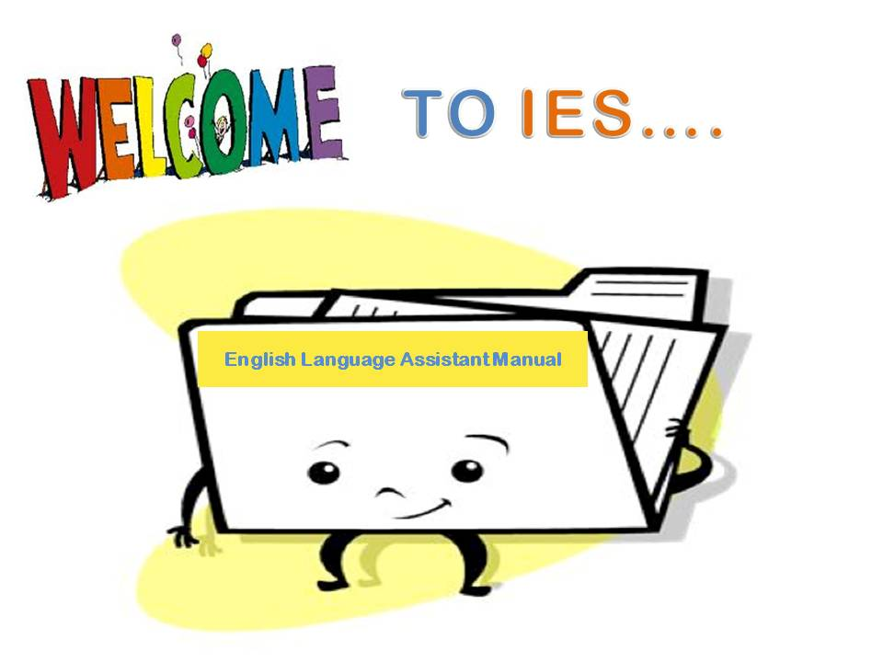

This document is a guide for English language assistants taking their first steps into the classroom.

The High School

The Principal is responsible for the Language Assistant while at the high school. The Bilingual Coordinator supervises and coordinates the Language Assistant’s activities.
Language Assistants are expected to inform the Principal, the Deputy Head of Studies, the Coordinator or the Head of Department of any incident that might arise while working at High School.
The Principal will inform the Subdirección General de Programas de Innovación of any irregularity or the Language Assistant’s failure to carry out his/her duties as required.

Principal:
Head of Studies:
Deputy Head of Studies:
English Coordinator:
Head of the English Department:

Address:
Telephone:
Fax:
E-mail:

How to get to High School

Webpage:

Twitter:

Facebook:

SCHOOL PLAN

SCHOOL CALENDAR

Which are my duties as language assistant?

You are expected to be punctual, flexible and have a positive attitude. Although this is an academic grant it is to be taken seriously and treated like a job. You may be removed from the position due to disciplinary problems or you may use them as a reference in the future if you do excellent work and enjoy the experience. It is up to you to be responsible and meet the standards and rules set forth by the program and your school.
Your basic duties are:
- To assist the regular staff at class
- To conduct conversation classes in the foreign language
- To supplement the classes with exercises in reading, dictation and oral composition
- To give pupils an insight to the way of life in your country.
- To prepare material.
- You may also be asked to participate in extra-curricular activities such as workshops, field trips, music and theatre performances, or sports events.
- To follow teachers´ instructions, cooperating with him/her at all times.
- To reinforce students’ oral skills.
- To carry out specific conversational tasks.
- To attend the language laboratory, computer room and multi-media centre with the students.
- To provide teaching material, especially authentic material from their countries of origin.
- To attend meetings along with the rest of the bilingual staff in order to organize class activities and plan ahead.
- To answer an online evaluation questionnaire concerning the activity developed during the academic year and also write a report of activities.

Educational Stages

Secondary Education (12-16 years old)
Compulsory Secondary Education is publicly financed and it is divided into four levels. Students enrolled in these levels are generally between twelve and sixteen years old. The subjects they study between stage one to three are: Science, Geography and History, Physical Education, Arts and Crafts, Spanish Language and Literature, a first Foreign Language, Mathematics, Technology, Music, Social and Civic Values, Biology and Geology, Physics and Chemistry and Tutorial.

Students can also choose from a number of optional subjects offered by the school, one of which is a second foreign language. The subjects studied in the fourth year are Physical Education, Geography and History, Social and Civic Values Spanish and Literature, Mathematics and a first Foreign Language.

Students have to study three other additional subjects, one of which can be a second Foreign Language. Students who have reached the basic competences and the objectives for this stage receive a Certificate in Compulsory Secondary Education that promotes them to Bachillerato, 1 st level Vocational Training or to the labour market. If they have not successfully completed Compulsory Secondary Education, they are given an Academic Certificate which states the years and subjects studied.

Bachillerato (16–18 years old)
Once the students have completed their studies in the Compulsory Secondary Education stage, they may continue their studies in 1st Bachillerato. Higher Secondary Education is not compulsory and is completed in two academic years. Any student who holds a Certificate in Secondary Education can enrol in this level. It is organized in different modules, it is flexible and various academic track options are available. Students can study Bachillerato for up to four years. There are three different modules which students can choose: Arts, Science, or Humanities and Social Studies. The subjects they study on the course depend on the module they have chosen, although some subjects are obligatory for all students.

Students who have successfully completed this academic period receive a Certificate in Higher Secondary Education that enables them to access a number of higher education options. In addition to this Certificate, students who apply to universities must have previously taken and passed a university entrance exam.

Vocational Training (15 - ... years old)
Specific Vocational Training is an educational option that prepares students for a professional activity and enables them to gain expertise and engage in different professions. Vocational Training is divided into training modules whose contents are organized by forming groups geared towards different professional sectors. The theoretical and practical material taught depends on the different activities developed in a career. The training stages include a module “placement period” (“Formación en Centros de Trabajo” - FCT) that takes place in companies or workplaces within a real working environment at the end of the stage. The aim of this module is to consolidate and conclude the training received at schools.
Bilingual Secondary Schools

This High School is Bilingual what means that students do not only study English as a foreign language but they are taught some subjects in English. In a Bilingual High School we find a Bilingual Section and Bilingual Programme.

Bilingual Section
Students study one hour of English Language and Literature a day, following the “Advanced English” curriculum designed by the Madrid Regional Ministry of Education, Youth and Sport.
So far in our High School the Bilingual Project has been implemented in ……..ESO. In 1º ESO Geography and History, Biology and Geology, ……. and …….. are taught in English whereas in ………………ESO Geography and History, ………….., ………………… are taught in English.

Bilingual Programme
Students study English Language one hour a day and …………. more subject(s) is/are taught in English.
Besides, students take part in extra-curricular activities in English, fostering a bilingual environment which, in turn, encourages them to practice their communicative skills in this language.

How many hours am I expected to be at school?
16 hours a week in class, usually four days a week, and some extra hours for coordination.

English Department

Technology Teacher

Art Teacher

Biology Teacher

Geography and History Teacher

OBSERVATION CHECKLIST
How is a lesson is developed? Here you are a checklist with the basics you should pay attention to. This checklist is based on the one proposed in Lavery, Clare (2001) Language assistants. British Council.

Group |  | Teacher |  |  |  | Number of students
Classroom |  | Number of lessons a week |  |  |  | Age of students
Classroom physical environment (lay out, light, cleanness, displays, etc.)
Lesson structure
- Start and end of lesson

- Timing and phasing

•Maintains students’ attention
Students’ grouping (individual / pair / group work)
Communication teacher-students
- Tone, volume and pace of voice

- Clarity of explanation

- Use of board

•Questioning technique
Classroom management (noise level, interruptions, teacher’s scanning, etc.)
Students’ general attitude towards learning (motivation, interest, participation, etc.)
How are disruptive students handled?
Textbook (title, type, characteristics, etc.)
Support materials used (handouts, graded readers, etc.)
Equipment used (CD, DVD, computers, projector, etc.)
In bilingual lessons, use of Spanish / English (when, why, etc.)

Students’ linguistic urgent needs (pronunciation, grammar, vocabulary, listening, etc.)

LANGUAGE ASSISTANT:
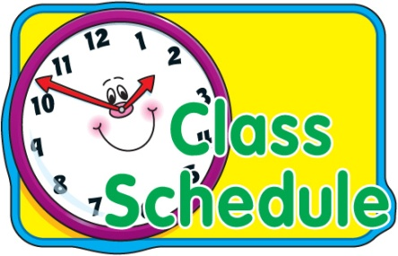
TIME | MONDAY | TUESDAY | WEDNESDAY | THURSDAY | FRIDAY
8:20-9:05

9:10-10:05

10:10-11:00

11:00 | BREAK
11:3012:20

12:25-13:15

13:20-14:10

14:15-15:05

Holidays and absences

- You are entitled to the same holidays at Christmas and Easter as the school staff. Your position ends on the 30th of June.
- You must comply with this calendar unless for unforeseen circumstances which have to be clearly justified in writing and authorized previously in writing by the Principal.
- Absences from the centre for medical reasons must be justified in writing by the doctor.

