My name is ………………………………………………………………………………………………
Date: ……………………………..

1 ) Match the animal to the group or subgroup.

Snail. * * Insects
Starfish and sea urchins * * Aracnids
Tarantula. * * Echinoderms
Bee. * * Gastropods

- Circle the invertebrate animals.

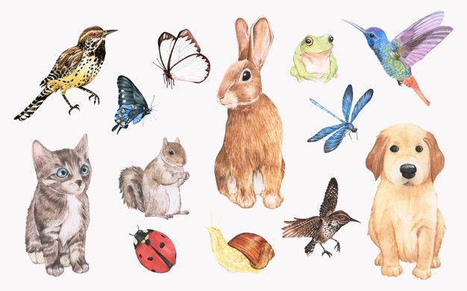

3 ) Write a cross ( X ) or a tick ( v ) according to the animals’ characteristics.
Animal’s name | Vertebrate | Invertebrate | It has scales. | It has wings | It can fly | It can slither
Snake
Ladybird

4 ) Write the name of a vertebrate animal . Write four characteristics of this animal as in the example.

Example:
Dog: It is a mammal. It’s viviparous. It has a tail. It can walk and run.

………………………: ……………………………………………………………………………………………

……………………………………………………………………………………………………………………..

……………………………………………………………………………………………………………………..

……………………………………………………………………………………………………………………..

5 ) Label the bones .
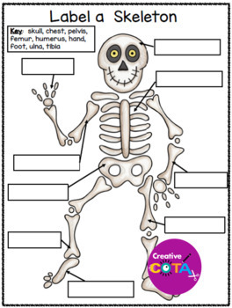
6) Label the muscles: abdominal muscles/ abdomen, biceps, triceps, chest/pectoralis.

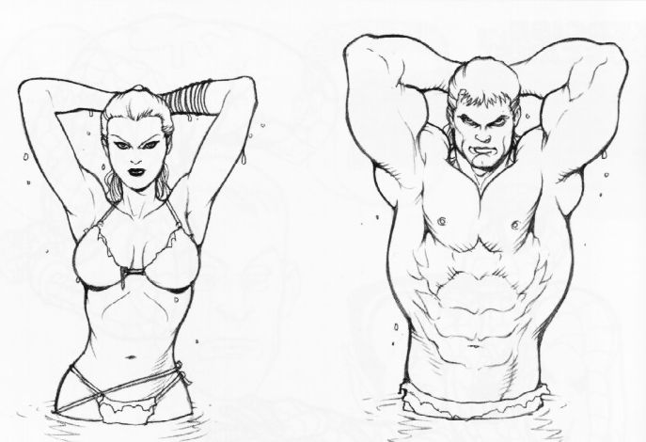

7 ) Copy the steps of digestion in the right order.

- Large intestine: The waste is stored ( and finally the waste is expelled from our body when we go to the toilet ).

- Stomach: The stomach juices and movements mash the food and turn it to paste.

- Esophagus: The food goes down the esophagus into the stomach.

- Mouth: We chew the food and mix it with saliva.

- Small intestine: The nutrients go through the walls of the intestine to the blood.

……………………………………………………………………………………………………………………..

……………………………………………………………………………………………………………………..

……………………………………………………………………………………………………………………..

……………………………………………………………………………………………………………………..

……………………………………………………………………………………………………………………..

……………………………………………………………………………………………………………………..

……………………………………………………………………………………………………………………..

……………………………………………………………………………………………………………………..

……………………………………………………………………………………………………………………..

……………………………………………………………………………………………………………………..

8 ) Write T (True) or F (false ) .

A. The heart is part of the reproductive system. …………
B. The blood transports the nutrients and oxygen to all the organs in our body. ………….

9) Write the names of the corresponding sense organs:

eyes – nose- skin – ears – mouth / tongue.

Sense of taste: ……………………
Sense of sight: ……………………
Sense of hearing : ……………………
Sense of smell: ……………………
Sense of touch: ……………………

10. Underline the healthy habits:

- Exercise every day.
- Wash your hands before eating.
- Go to bed late.
- Brush your teeth.
- Eat vegetables and fruit.

