My name is …………………………………………………
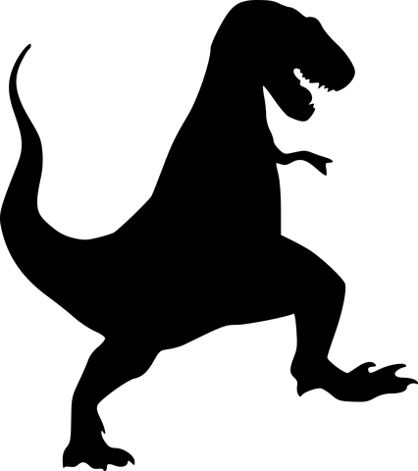
RESEARCH ABOUT DINOSAURS.

1. DINOSAUR’S S NAME: …………………………………………………………

2. DIet. It eats : ………………………………….So it is …………………….
( hervibore/carnivore/omnivore ).

3: CHARACTERISTICS: It has got……………………………………………...
( wings, tail, scales…).

4. ABILITIES . IT CAN: …………………………………………………………...
(fly, run, walk… ).

I DRAW MY DINOSAUR:

